

Department of Electronics & Telecommunication Engineering

Synopsis for the Major Project Phase I-BET606
“Decentralized Firmware Integrity System for IoT Devices Using Blockchain”

Batch No: 16 |  | Guide Name: Dr. Mallikarjuna Gowda C P |  | Submission Date:  06/02/2026
Project Title: Decentralized Firmware Integrity System for IoT Devices Using Blockchain
Sl No | USN |  | Name
1 | 1BY23ET016 |  | Drupadsurya A
2 | 1BY23ET066 |  | Radhesh Shenoy
3 | 1BY23ET067 |  | Piyush Jha
4 | 1BY23ET069 |  | Syed Taqqeeulla
Project Execution Place |  |  | In-house  Not Applicable (In-house Academic Project)
Project Category |  |  | Product Development

2025-2026

1. Introduction

The Internet of Things (IoT) has emerged as a transformative technological paradigm, fundamentally reshaping critical infrastructure sectors including healthcare delivery systems, industrial automation networks, intelligent power grids, and autonomous vehicular platforms. Contemporary analyses indicate that the global IoT ecosystem comprises approximately 15 billion interconnected devices as of 2024, with authoritative projections forecasting exponential expansion to 29 billion devices by 2030. This unprecedented proliferation of embedded systems across mission-critical domains has introduced substantial security imperatives, as these devices increasingly govern essential services upon which modern society depends. The convergence of connectivity and physical-world interaction renders IoT security a matter of paramount importance for organisational resilience.

Firmware constitutes the foundational software layer executing in direct proximity to device hardware, governing core operational behaviour, communication protocols, and security enforcement mechanisms. Unlike application software, which operates within protected environments, firmware executes with elevated privileges and direct hardware access, making it a particularly attractive target for malicious actors. Compromised firmware can enable unauthorised system access, sensitive data exfiltration, coordinated network attacks, and complete device subversion. Historical incidents have demonstrated that firmware vulnerabilities in IoT devices can result in large-scale security breaches affecting millions of devices and critical services simultaneously.

Existing firmware management approaches exhibit fundamental architectural limitations that undermine their security efficacy. Conventional update mechanisms rely upon centralised distribution servers, presenting inherent single points of failure susceptible to server compromise and network-based attacks. Traditional cryptographic verification methods concentrate trust in manufacturer-controlled infrastructure, lacking hardware-rooted mechanisms for independent device integrity validation. Furthermore, emerging computational technologies pose significant threats to current cryptographic standards, raising concerns about the long-term security of firmware protection mechanisms deployed in devices with extended operational lifecycles.

This project proposes a Decentralised Firmware Integrity System that addresses these security gaps through the integration of distributed ledger technology, hardware-anchored trust mechanisms, and modern cryptographic primitives designed for long-term security.

2. Literature Survey
The domain of firmware security and blockchain-based integrity verification has witnessed substantial research contributions in recent years. This section presents a review of pertinent literature from 2022 to 2025 that informs the theoretical foundation and technical approach of the proposed system.

Blockchain technology has been explored by several researchers for securing Internet of Things (IoT) firmware updates. A lightweight blockchain solution for data integrity and traceability in IoT networks was proposed in [1], adapting Distributed Ledger Technology (DLT) to the Long-Range Wide Area Network (LoRaWAN) protocol. This implementation offers data integrity guarantees without requiring complex consensus algorithms, demonstrating suitability for resource-constrained wireless sensor networks. Another study explored blockchain-based solutions for distributing IoT firmware updates using Ethereum and decentralised storage mechanisms to eliminate single points of failure [2]. A highly secure IoT firmware update mechanism using blockchain was developed in [3], ensuring firmware source verification, integrity validation, and complete traceability while reducing storage requirements.

With growing concerns over quantum computing threats, researchers have started exploring Post-Quantum Cryptography (PQC) for IoT applications. A comprehensive survey on post-quantum blockchain security for the IoT was conducted in [4], examining various post-quantum cryptosystems and their suitability for securing blockchain-based IoT applications. This analysis addresses the vulnerability of traditional cryptographic approaches to quantum computing attacks. Another study presented an approach integrating post-quantum cryptography with blockchain to secure low-cost IoT devices [5], implementing the Dilithium-5 digital signature algorithm and demonstrating practical deployment feasibility for low-power microcontrollers.

Hardware-based device authentication using Physically Unclonable Functions (PUFs) has also
gained significant research attention. A blockchain-PUF-based secure mutual authentication.

A scheme for IoT was proposed in [6], combining blockchain immutability with PUF technology to prevent device tampering and identity forgery. A lightweight XOR-Ring Oscillator PUF (ROPUF)-based authentication scheme was developed in [7], demonstrating significant resource
efficiency suitable for constrained embedded devices while maintaining robust security properties.
These approaches provide hardware-rooted trust anchors, though few of them address the broader problem of firmware integrity verification.

For efficient verification of large firmware images, Merkle tree structures have been studied extensively. The security of Merkle trees in IoT environments was evaluated in [8], providing a theoretical framework to calculate the probability of data falsification attacks and offering critical insights for optimising Merkle tree parameters. Similarly, lightweight anomaly detection methods have been proposed for edge computing applications. A real-time anomaly detection framework utilising unsupervised deep learning techniques, including Autoencoder-Long Short-Term Memory (AE-LSTM) and Variational Autoencoder-LSTM (VAE-LSTM) architectures, was proposed in [9], enabling on-device anomaly detection without continuous cloud communication. A lightweight autoencoder architecture for anomaly detection on edge IoT platforms was introduced in [10], demonstrating high detection accuracy on resource-constrained platforms.

While the existing literature covers blockchain-based updates, quantum-resistant cryptography, hardware authentication, Merkle tree verification, and anomaly detection as separate research areas, most approaches address only one or two aspects of firmware security. Limited work has been done on combining these mechanisms within a unified framework. Additionally, there is insufficient focus on integrating automated security vetting before firmware is registered on the blockchain, and hardware-level rollback mechanisms for failed updates are rarely discussed. This research gap motivates the proposed Decentralised Firmware Integrity System, which aims to integrate these complementary techniques into a cohesive firmware integrity framework suitable for IoT deployments.

3. Motivation

The rapid growth of Internet of Things (IoT) devices across critical sectors such as healthcare, industrial automation, smart cities, and transportation has created new security challenges that cannot be ignored. As of 2024, there are over 15 billion connected devices worldwide, and this number is expected to double within the next few years. These devices often operate in sensitive

environments where a security breach can have serious consequences, ranging from data theft to physical harm. Ensuring that the firmware running on these devices is authentic and untampered with has therefore become a pressing concern.
Firmware is the core software that controls how an IoT device operates. Unlike regular applications, firmware runs with high privileges and has direct access to hardware components. This makes it an attractive target for attackers. Once firmware is compromised, an attacker can gain complete control over the device, steal sensitive information, or use it to launch attacks on other systems. The 2016 Mirai botnet attack demonstrated this risk clearly, when hundreds of thousands of IoT devices were compromised through weak firmware security and used to disrupt major internet services across multiple countries.
Another major concern is the vulnerability of centralised firmware update systems. Most manufacturers distribute firmware updates through their own servers, which creates a single point of failure. If an attacker compromises this server, they can push malicious firmware to the entire fleet of devices. The 2020 SolarWinds supply chain attack showed how devastating such an incident can be, with malicious code being distributed through legitimate update channels to thousands of organisations. These incidents highlight the need for a more resilient and transparent approach to firmware distribution.
Additionally, there is growing concern about the long-term security of current cryptographic methods. With advances in quantum computing, the algorithms used today for signing and verifying firmware may become vulnerable in the coming years. Devices deployed now may remain in operation for a decade or more, making it important to consider future-proof security measures. At the same time, most IoT devices have limited computational resources, so any security solution must be lightweight enough to run efficiently on constrained hardware.
These factors together point to the need for a firmware integrity system that does not rely on centralised infrastructure, provides verifiable and tamper-proof records of firmware authenticity, and is designed to remain secure against both current and emerging threats. This forms the core motivation behind the proposed project.
4. Existing System
The current approach to IoT firmware management relies primarily on centralised update servers operated by device manufacturers. In this model, firmware images are stored on manufacturer-

controlled servers, and devices periodically connect to these servers to check for available updates. When a new firmware version is released, devices download it directly from the server and apply the update. This centralised distribution model remains a widely adopted approach in the industry due to its simplicity and ease of fleet management.

To ensure that firmware originates from a trusted source, most systems employ Public Key Infrastructure (PKI) and digital signatures. The manufacturer signs firmware images using a private key, and the corresponding public key is embedded in the device during manufacturing, typically in the form of X.509 digital certificates. Before installing any firmware update, the device computes a cryptographic hash of the received image and verifies the digital signature to confirm authenticity and integrity. Various asymmetric cryptographic algorithms are commonly used for this purpose.
Over-the-Air (OTA) update mechanisms have become essential in modern IoT deployments, allowing firmware to be updated remotely without physical access to the device. Secure OTA implementations utilise Transport Layer Security (TLS) for encrypted communication, along with certificate-based authentication to validate the identities of both devices and servers. Industry best practices also include staged rollouts, where updates are deployed to small batches of devices first before wider distribution, and delta updates, where only the changed portions of firmware are transmitted to reduce bandwidth usage.
Many IoT devices implement secure boot mechanisms to verify firmware integrity during the device startup process. Secure boot establishes a "chain of trust" starting from an immutable hardware root of trust, often stored in read-only memory. Each stage of the boot process verifies the next component using digital signatures or cryptographic hashes before execution is allowed to proceed. Some devices incorporate Hardware Security Modules (HSMs) or Trusted Platform Modules (TPMs) to provide secure storage for cryptographic keys and to perform sensitive operations in a protected environment.
Firmware version management and certificate handling are also integral parts of existing systems. Manufacturers maintain records of deployed firmware versions across their device fleet, enabling coordinated update rollouts and compliance monitoring. Rollback protection mechanisms prevent devices from reverting to older, potentially vulnerable firmware versions. Certificate revocation is handled through Certificate Revocation Lists (CRLs) or Online Certificate Status Protocol (OCSP), allowing manufacturers to invalidate compromised signing certificates. Emerging regulatory frameworks such as the European Union Cyber Resilience Act (CRA) are now mandating these security measures, with full enforcement expected by 2027.
5. Limitations of Existing System
The centralised firmware update architecture, while widely adopted, introduces a significant single point of failure. If the central update server is compromised, attackers can potentially distribute malicious firmware to all connected devices in the fleet. Similarly, server downtime due to infrastructure failures or denial-of-service attacks can prevent legitimate security patches from reaching devices when they are most needed. This concentration of control creates a high-value target for adversaries seeking to compromise large numbers of devices simultaneously.
Existing systems place considerable trust in the device manufacturer's infrastructure and personnel. The security of the entire update process depends on the integrity of the manufacturer's signing keys and internal controls. If these keys are compromised or if a malicious insider gains access to the signing infrastructure, unauthorised firmware can be distributed without detection. End users and organisations have limited ability to independently verify whether the firmware they receive has been properly authorised through legitimate channels.
Certificate management presents ongoing operational challenges in IoT environments. Certificate Revocation Lists (CRLs) may take significant time to propagate, during which a compromised certificate may still be accepted by devices. The Online Certificate Status Protocol (OCSP), while offering real-time status checks, introduces additional latency and may not be practical for resource-constrained devices with intermittent connectivity. Managing certificates across potentially millions of devices with varying lifespans adds significant administrative complexity.
Transparency and auditability remain limited in current implementations. Organisations deploying IoT devices often have no way to independently trace the provenance of firmware or verify the complete history of updates applied to their devices. This lack of visibility complicates forensic investigations following security incidents and makes it difficult to demonstrate compliance with emerging regulatory requirements. The absence of immutable records means that update histories may not always be maintained in an immutable manner.
Scalability becomes a concern during mass update scenarios, such as when a critical vulnerability requires immediate patching across a large device fleet. Centralised servers may struggle to handle the surge in concurrent update requests, leading to delays in deploying time-sensitive security fixes. Additionally, the traditional IoT supply chain often lacks sufficient transparency, making it difficult to detect if firmware has been tampered with during distribution. Third-party components
Aspect | Existing System | Proposed System
Update model | Centralized server | Decentralized blockchain registry
Trust | Manufacturer dependent | Cryptographic & distributed trust
Verification | Signature check only | Merkle proof + hash + consensus
Transparency | Limited audit trail | Immutable on chain logs
Device identity | Certificates | PUF-based hardware identity
Rollback | Limited | Dual partition automatic rollback
Scalability | Server bottleneck | Batch proof verification
Future security | Classical cryptography | Post-quantum readiness analysis
and libraries embedded in firmware may contain unpatched vulnerabilities that are difficult to identify without proper visibility into the software composition.

6. Proposed System
Immutable Firmware Registry Using Blockchain
The proposed system addresses the identified limitations by introducing a decentralised firmware integrity architecture that eliminates reliance on centralised infrastructure while providing verifiable, tamper-proof firmware management for IoT devices. At its core, the system uses a permissioned blockchain network as an immutable firmware registry, where cryptographic hashes, version metadata, and digital signatures of legitimate firmware are permanently recorded. This approach ensures that firmware provenance can be independently verified by any network participant without requiring trust in a single centralised authority.
Merkle Tree–Based Batch Proof Verification
To address the scalability challenges associated with blockchain verification on resource-constrained devices, the proposed system employs Merkle tree-based batch proof verification. Rather than requiring each IoT device to download and process the entire blockchain, devices receive compact Merkle proofs that allow them to verify the authenticity of specific firmware entries. This approach significantly reduces the computational and storage requirements on the device side, making blockchain-based verification practical for constrained embedded environments.
Lightweight Verification Client for IoT Devices
A lightweight verification client is designed for deployment on IoT devices. This client handles communication with the blockchain network, processes Merkle proofs, and performs local hash verification of downloaded firmware images. The client is designed to operate with minimal memory and processing overhead, allowing even resource-limited devices to participate in the verification process. The design prioritises compatibility with common embedded architectures without requiring specialised hardware.
Post-Quantum Security Analysis Support
The system incorporates post-quantum cryptographic analysis to address concerns about long-term security. While a full hardware implementation of post-quantum signatures is beyond the scope of a lab-scale prototype, the proposed system includes simulation and analysis of lattice-based signature schemes to evaluate their feasibility and performance characteristics on constrained devices. This analysis provides a foundation for future quantum-resistant implementations as post-quantum standards mature.
Mesh-Based Local Consensus for Update Validation
To enhance resilience in distributed deployments, the system introduces a mesh-based local consensus mechanism among nearby devices before accepting firmware updates. Devices within a local network can share and cross-verify firmware update information, reducing dependence on external infrastructure and providing an additional layer of validation. This peer-to-peer verification helps detect inconsistencies or potentially malicious updates before they are applied.
Hash Commitment Verification Mechanism
A hash commitment scheme inspired by zero-knowledge principles is incorporated to allow devices to verify firmware integrity without exposing the actual firmware contents during the verification process. The device computes a cryptographic hash of the received firmware and compares it against the committed hash stored on the blockchain, ensuring integrity while avoiding unnecessary exposure of firmware contents during verification.
PUF-Based Hardware Identity for Devices
For decentralised device identity and trust anchoring, the system explores the integration of Physically Unclonable Function (PUF)-based hardware identities. PUFs leverage inherent manufacturing variations to generate unique, unclonable device fingerprints that can be registered on the blockchain. This approach provides a hardware-rooted trust anchor for device authentication, preventing device impersonation and cloning attacks without relying on centrally managed credentials.
Adaptive Validation Policies from On-Chain Logs
The proposed system also incorporates adaptive validation policies based on historical firmware update logs stored on the blockchain. Devices and network administrators can configure trust thresholds and verification requirements based on observed patterns, adjusting security posture in

response to detected anomalies. The overall system is designed for feasibility at a lab-scale prototype level, with simulation support for components that require specialised hardware or extended deployment environments. This approach allows the core concepts to be demonstrated and validated within an academic project context while establishing a clear path for future enhancements.
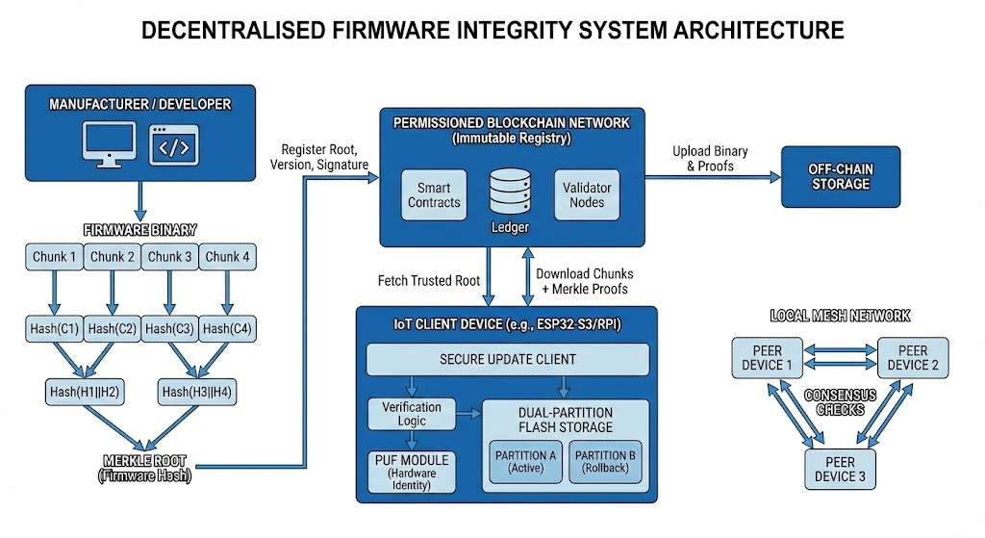
Figure 1: System Architecture of the Proposed Decentralised Firmware Integrity System
7. System Requirement Specifications
7.1 Functional Requirements
- The system shall utilise a permissioned blockchain network to serve as an immutable firmware registry for storing firmware metadata, cryptographic hashes, digital signatures, and version information.
- The system shall generate Merkle tree proofs for registered firmware entries, enabling efficient batch verification without requiring devices to download and process the complete blockchain.
- The system shall provide a lightweight verification client capable of running on resource-constrained IoT devices to perform firmware authenticity checks using Merkle proofs and hash comparison.
- The system shall support registration of device identities using hardware fingerprints derived from Physically Unclonable Functions (PUFs) on the blockchain ledger.
- The system shall implement a mesh-based local consensus mechanism allowing neighbouring devices to cross-verify firmware update information before applying updates.
- The system shall compute and compare cryptographic hash commitments to verify firmware integrity without exposing firmware contents during the verification process.
- The system shall maintain immutable logs of all firmware update events, including timestamps, device identifiers, firmware versions, and verification outcomes for auditing and adaptive policy enforcement.
- The system shall implement a dual-partition rollback mechanism to restore the previous firmware version automatically if verification or installation of a new update fails.
- The system shall support adaptive validation policies that adjust verification thresholds and trust requirements based on historical update patterns and detected anomalies stored on-chain.
- The system shall provide a simulation environment for analysing post-quantum signature scheme performance on constrained device profiles.
7.2 Non-Functional Requirements
- Performance: The system shall complete firmware hash verification within a few seconds on a representative embedded device profile under normal operating conditions.
- Memory Footprint: The lightweight verification client shall operate with a minimal memory footprint suitable for resource-constrained IoT devices.
- Latency: The system shall achieve blockchain transaction finality within acceptable time limits for firmware registration operations using a lightweight consensus mechanism.
- Availability: The system shall maintain local verification capability and continue operations even when connectivity to the main blockchain network is temporarily unavailable.
- Security Strength: The system shall ensure data integrity using cryptographic hash functions with adequate security strength for all firmware verification operations.
- Scalability: The system shall support multiple concurrent device verification requests in the lab-scale prototype deployment.
- Tamper Evidence: The system shall provide tamper-evident logging such that any modification to historical records is cryptographically detectable.
- Modularity: The system shall be designed with modular architecture to allow future integration of post-quantum cryptographic algorithms without requiring complete system redesign.
- Robustness: The system shall be resilient to interruptions such as power loss or connectivity issues during the update process, preventing devices from becoming inoperable.
- Testability: The system shall be deployable and testable in a lab-scale prototype environment with simulation support for components requiring specialised hardware or extended infrastructure.
8. Proposed Methodology
The implementation of the Decentralized Firmware Integrity System follows a structured methodology divided into distinct phases, each addressing specific components of the architecture. The phases are designed to enable progressive development and testing within a lab-scale prototype environment.
Step 1: Blockchain Network Setup and Smart Contract Development The first phase involves establishing the permissioned blockchain network that serves as the immutable firmware registry. A lightweight blockchain framework with efficient consensus is deployed on a local server or cloud environment. Smart contracts are developed to handle firmware registration, metadata storage, and access control logic. The contracts include functions for registering new firmware entries, querying firmware information by device type and version, and logging update events. This phase is implemented entirely in software using standard blockchain development tools.
Step 2: Firmware Hashing and Merkle Tree Construction In this phase, a firmware processing module is developed to compute cryptographic hashes of firmware images and construct Merkle trees from firmware registries. The module generates Merkle roots that are stored on the blockchain and produces Merkle proofs for individual firmware entries. This enables devices to verify firmware authenticity by checking compact proofs rather than accessing the complete registry. The module is implemented as a server-side software component that interfaces with the blockchain smart contracts.
Step 3: Lightweight Verification Client Development A lightweight verification client is developed for deployment on embedded IoT devices. The client is designed with minimal memory footprint and includes functionality for communicating with the blockchain network, receiving and validating Merkle proofs, and computing local firmware hashes for comparison. The client implements the hash commitment verification logic, allowing devices to confirm firmware integrity without exposing firmware contents during the process. This component is implemented in software and tested on representative embedded development platforms.
Step 4: Device Identity and PUF Integration This phase addresses hardware-rooted device identity using Physically Unclonable Function (PUF) concepts. For the prototype, PUF behaviour is demonstrated through simulation, modelling the generation of unique device fingerprints based on hardware characteristics. The simulated PUF identities are registered on the blockchain during device enrolment. The integration demonstrates how hardware-derived identities can be used for decentralized device authentication without relying on centrally managed credentials. Full hardware PUF implementation is identified as a future enhancement requiring specialised embedded components.
Step 5: Mesh-Based Validation and Rollback Mechanism A mesh-based local consensus mechanism is implemented to enable neighbouring devices to share and cross-verify firmware update information before applying updates. This component is demonstrated through software simulation of a local device network, showing how peer devices can detect inconsistencies in firmware distribution. Additionally, a dual-partition rollback mechanism is implemented on the embedded client, enabling automatic restoration of previous firmware if verification fails. The rollback functionality is tested on the embedded development platform to validate recovery behaviour.
Step 6: Integration, Testing, and Validation The final phase integrates all components into a complete prototype system. End-to-end testing is conducted to validate the firmware registration, distribution, verification, and update workflow. Test scenarios include successful firmware updates, detection of tampered firmware, rollback upon verification failure, and mesh-based consensus behaviour. Performance metrics such as verification time, memory usage, and transaction latency are measured and documented. Post-quantum signature schemes are evaluated through simulation to assess their feasibility for future integration. The prototype is validated against the defined functional and non-functional requirements.
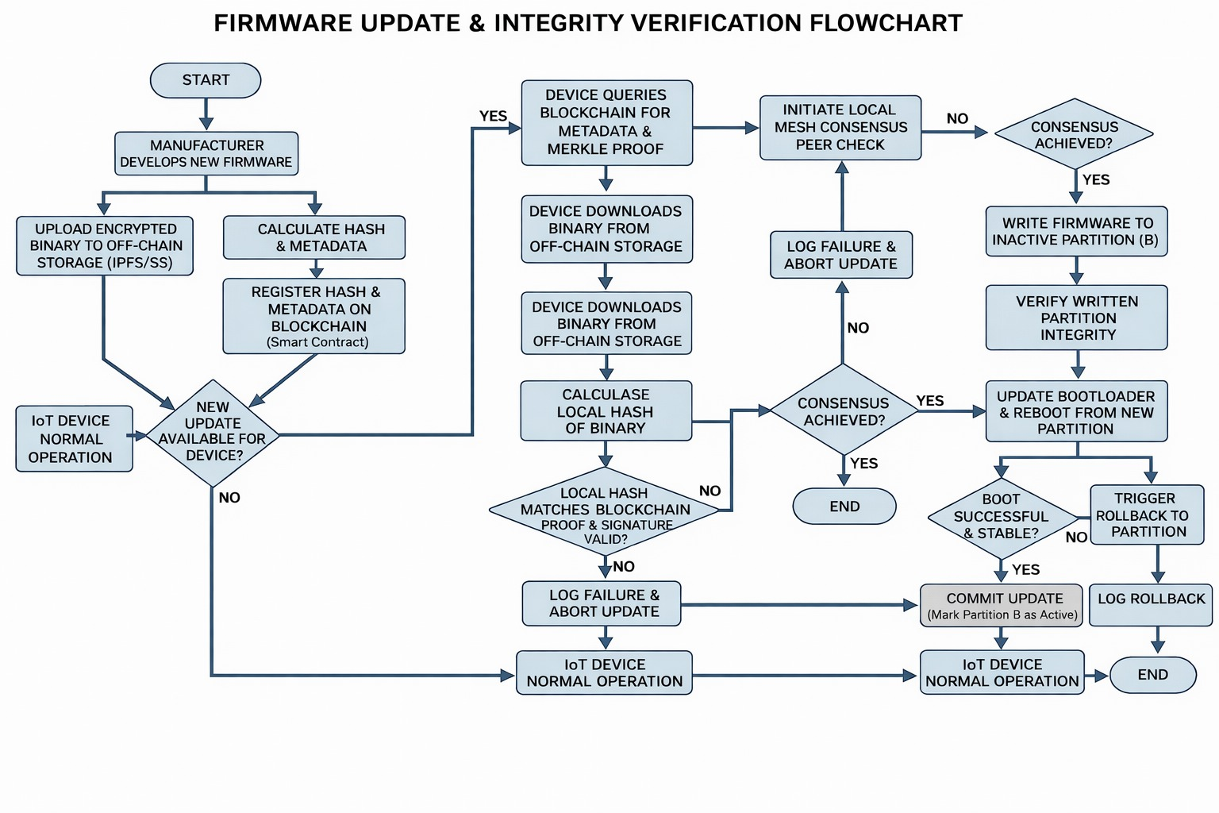
Figure 2: Firmware Update and Integrity Verification Workflow in the Proposed System
9. References
[1] L. García, C. Cancimance, R. Asorey-Cacheda, C.-L. Zuniga-Canon, A.-J. Garcia-Sanchez, and J. Garcia-Haro, "Lightweight Blockchain for Data Integrity and Traceability in IoT Networks," IEEE Access, vol. 13, pp. 1–15, Jan. 2025, doi: 10.1109/ACCESS.2025.3567773.
[2] V. Biró, W.-Y. Chiu, and W. Meng, "Securing IoT Firmware Dispatch Systems with Blockchain," in Proc. 2023 IEEE Int. Conf. Blockchain (Blockchain), Hainan, China, Dec. 2023, pp. 267–274, doi: 10.1109/Blockchain60715.2023.00046.
[3] M. A. Uddin, A. Stranieri, I. Gondal, and V. Balasubramanian, "A Highly Secure IoT Firmware Update Mechanism Using Blockchain," Sensors, vol. 22, no. 2, Art. no. 530, Jan. 2022, doi: 10.3390/s22020530.
[4] H. Gharavi, J. Granjal, and E. Monteiro, "Post-Quantum Blockchain Security for the Internet of Things: Survey and Research Directions," IEEE Commun. Surveys Tuts., vol. 26, no. 3, pp. 1878–1915, Jan. 2024, doi: 10.1109/COMST.2024.3355222.[5] A. Castiglione, J. G. Esposito, V. Loia, M. Nappi, C. Pero, and M. Polsinelli, "Integrating Post-Quantum Cryptography and Blockchain to Secure Low-Cost IoT Devices," IEEE Trans. Ind. Informat., vol. 21, no. 2, pp. 1674–1683, 2025, doi: 10.1109/TII.2024.3485796.
[6] E.-J. Li, J.-H. Cheng, C.-C. Yang, and C.-L. Chen, "A Blockchain-PUF-based Secure Mutual Authentication Scheme for IoT," in Proc. 2024 IEEE Conf. Commun. Netw. Security (CNS), San Antonio, TX, USA, Sep. 2024, pp. 1–9, doi: 10.1109/CNS62487.2024.10735610.
[7] A. Oun and M. Niamat, "PUF-Based Authentication for the Security of IoT Devices," in Proc. 2023 IEEE Int. Conf. Electro Inf. Technol. (eIT), Romeoville, IL, USA, May 2023, pp. 1–6, doi: 10.1109/eIT57321.2023.10187363.
[8] O. Kuznetsov, E. Frontoni, and D. Mohanty, "Evaluating the Security of Merkle Trees in the Internet of Things: An Analysis of Data Falsification Probabilities," Cryptography, vol. 8, no. 3, Art. no. 33, Jul. 2024, doi: 10.3390/cryptography8030033.
[9] R. Sanyour, M. Abdullah, and S. Abdullah, "A Light-Weight Real-Time Anomaly Detection Framework for Edge Computing," in Proc. Int. Conf. Adv. Intell. Syst. Inform. (AISI 2023), Cham, Switzerland: Springer, 2023, pp. 457–468, doi: 10.1007/978-3-031-33743-7_37.
[10] S. Goyal, N. Sharma, and R. Kumar, "Intrusion Detection for Edge-IoT Using LSTM-Autoencoder," Sensors, vol. 24, no. 9, Art. no. 2833, Apr. 2024, doi: 10.3390/s24092833.
[11] S. B. Chandar M and S. Arunkumar, "Implementation and Verification of Secure Boot in Embedded Systems," in Proc. 2024 Int. Conf. Adv. Modern Age Technol. Health Eng. Sci. (AMATHE), Chennai, India, May 2024, pp. 1–6, doi: 10.1109/AMATHE61652.2024.10582165.
[12] M. Al-Rubaie, M. Al-Shammari, and A. Al-Amidie, "MQTree: Secure OTA Protocol Using MQTT and MerkleTree," Sensors, vol. 24, no. 5, Art. no. 1447, Feb. 2024, doi: 10.3390/s24051447.
[13] N. Aoki, A. Takefusa, Y. Ishikawa, Y. Ono, E. Sakane, and K. Aida, "ZT-OTA Update Framework for IoT Devices Toward Zero Trust IoT," in Proc. 2024 IEEE 48th Annu. Comput. Softw. Appl. Conf. (COMPSAC), Osaka, Japan, Jul. 2024, pp. 2108–2113, doi: 10.1109/COMPSAC61105.2024.00352.
[14] J. B. Burgos and M. Pustišek, "Decentralised IoT Data Authentication with Signature Aggregation," Sensors, vol. 24, no. 3, Art. no. 1037, Feb. 2024, doi: 10.3390/s24031037.
[15] G. A. Pierro, L. Cocco, R. Ferraris, and R. Tonelli, "Besu vs. Quorum: Comparative Analysis in the Context of Simulated Energy Communities," in Proc. CEUR Workshop, vol. 3791.

